Setup Development Environment

#Assignment: Setting Up Your Developer Environment

#Objective: This assignment aims to familiarize you with the tools and configurations necessary to set up an efficient developer environment for software engineering projects. Completing this assignment will give you the skills required to set up a robust and productive workspace conducive to coding, debugging, version control, and collaboration.

#Tasks:

1. Select Your Operating System (OS): Choose an operating system that best suits your preferences and project requirements. Download and Install Windows 11. <https://www.microsoft.com/software-download/windows11>
2. Install a Text Editor or Integrated Development Environment (IDE): Select and install a text editor or IDE suitable for your programming languages and workflow. Download and Install Visual Studio Code. <https://code.visualstudio.com/Download>
3. Set Up Version Control System: Install Git and configure it on your local machine. Create a GitHub account for hosting your repositories. Initialize a Git repository for your project and make your first commit. <https://github.com>
4. Install Necessary Programming Languages and Runtimes: Instal Python from <http://wwww.python.org> programming language required for your project and install their respective compilers, interpreters, or runtimes. Ensure you have the necessary tools to build and execute your code.
5. Install Package Managers: If applicable, install package managers like pip (Python).
6. Configure a Database (MySQL): Download and install MySQL database. <https://dev.mysql.com/downloads/windows/installer/5.7.html>
7. Set Up Development Environments and Virtualization (Optional): Consider using virtualization tools like Docker or virtual machines to isolate project dependencies and ensure consistent environments across different machines.
8. Explore Extensions and Plugins: Explore available extensions, plugins, and add-ons for your chosen text editor or IDE to enhance functionality, such as syntax highlighting, linting, code formatting, and version control integration.
9. Document Your Setup: Create a comprehensive document outlining the steps you've taken to set up your developer environment. Include any configurations, customizations, or troubleshooting steps encountered during the process.

#Deliverables:

* Document detailing the setup process with step-by-step instructions and screenshots where necessary.
* A GitHub repository containing a sample project initialized with Git and any necessary configuration files (e.g., .gitignore).
* A reflection on the challenges faced during setup and strategies employed to overcome them.

#Submission: Submit your document and GitHub repository link through the designated platform or email to the instructor by the specified deadline.

#Evaluation Criteria:\*\*

* Completeness and accuracy of setup documentation.
* Effectiveness of version control implementation.
* Appropriateness of tools selected for the project requirements.
* Clarity of reflection on challenges and solutions encountered.
* Adherence to submission guidelines and deadlines.

Objective

This task is designed to acquaint me with the tools and configurations required to establish an effective developer environment for software engineering projects. Upon successful completion, I aim to possess the requisite skills for establishing a resilient and efficient workspace conducive to coding, debugging, version control, and collaborative work.

Task and Steps

O.S INSTALLATION

1. Selecting my operating system.

-The operating system I choose for this particular task is Windows 11.

-Below are among the steps I chose to accomplish this objective:

I first began by ensuring my system met the minimum requiremnts for the installation of the O.S.

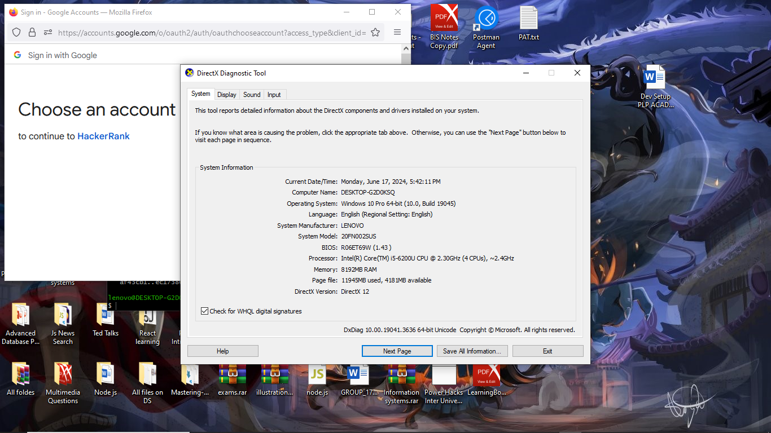

From the screenshot above I discovered that my system indeed met the minimum requirements which were :

* Processor: 1 gigahertz (GHz) or faster with at least 2 cores on a compatible 64-bit processor or System on a Chip (SoC)
* RAM: 4 GB or more
* Storage: 64 GB or larger
* Firmware: UEFI, Secure Boot capable
* TPM: Trusted Platform Module (TPM) version 2.0
* Graphics card: DirectX 12 compatible graphics / WDDM 2  
   Among others.

1. Backup my Data

* This is the second step I took in ensuring that I was indeed setup for the installation.
* All my data was backed up in an external hard disk drive that I own.

1. Downloading the windows i11.

I had a windows 11 software that I had downloaded as clearly indicated in the screen shot below.

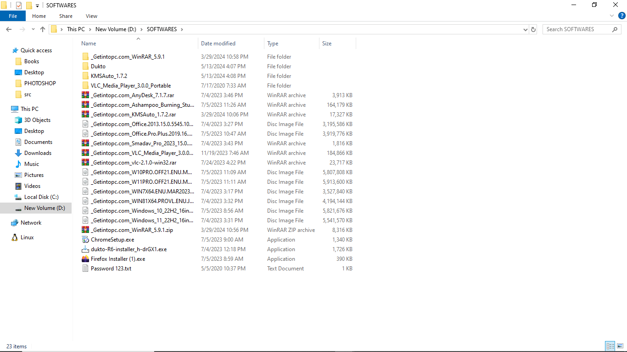

1. Installing the window 11

First I copied the downloaded OS into a flash drive. Then I Switch off the laptop to boot from the Flash disk. I did this by changing the boot order in the Bios Settings.

Once the windows setup started, I selected my language and key board preferences then went Next.

Then I was prompted to click install now.

I was prompted again to enter a product key or choose “I don’t have a product key which of course I selected. I also accepted the terms and conditions and then clicked next.

I chose a custom install option. Then next I did the partitioning of the Solid Disk Drive in my laptop. After that the installation process began.

My laptop restarted four times before the all process completed and was a complete success.

I followed some on-screen instructions for the setup of windows 11 including setting up my region, account preferences and many others.

Post Installation

I basically did the following:

-I updated the drivers.

-I installed updated

-I restored all data from backup.

TEXT EDITOR INSTALLATION

-My preffered Text Editor was Visual Studio Code. I visited their official webpage <https://code.visualstudio.com/Download> And below is a screen shot of the page:

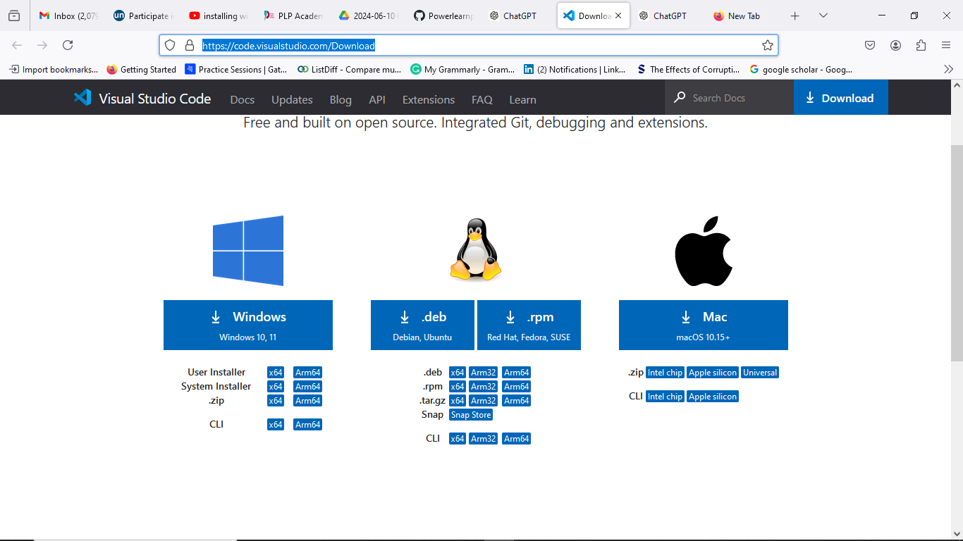

Below is a screen shot of the Welcome page after successful installation.  
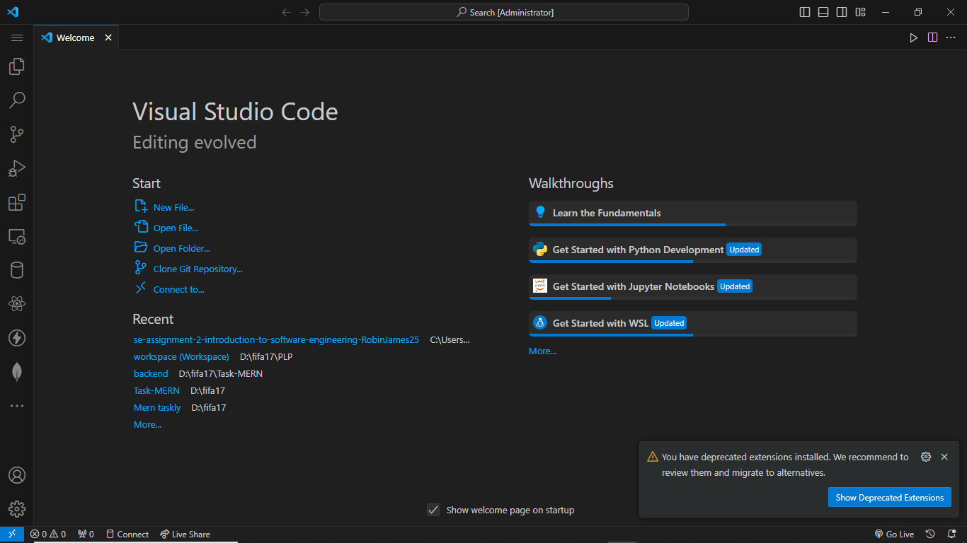

GIT INSTALLATION

I visited the official git website <https://www.git-scm.com/> and downloaded the open source version control system. Below is a screen shot of the website:

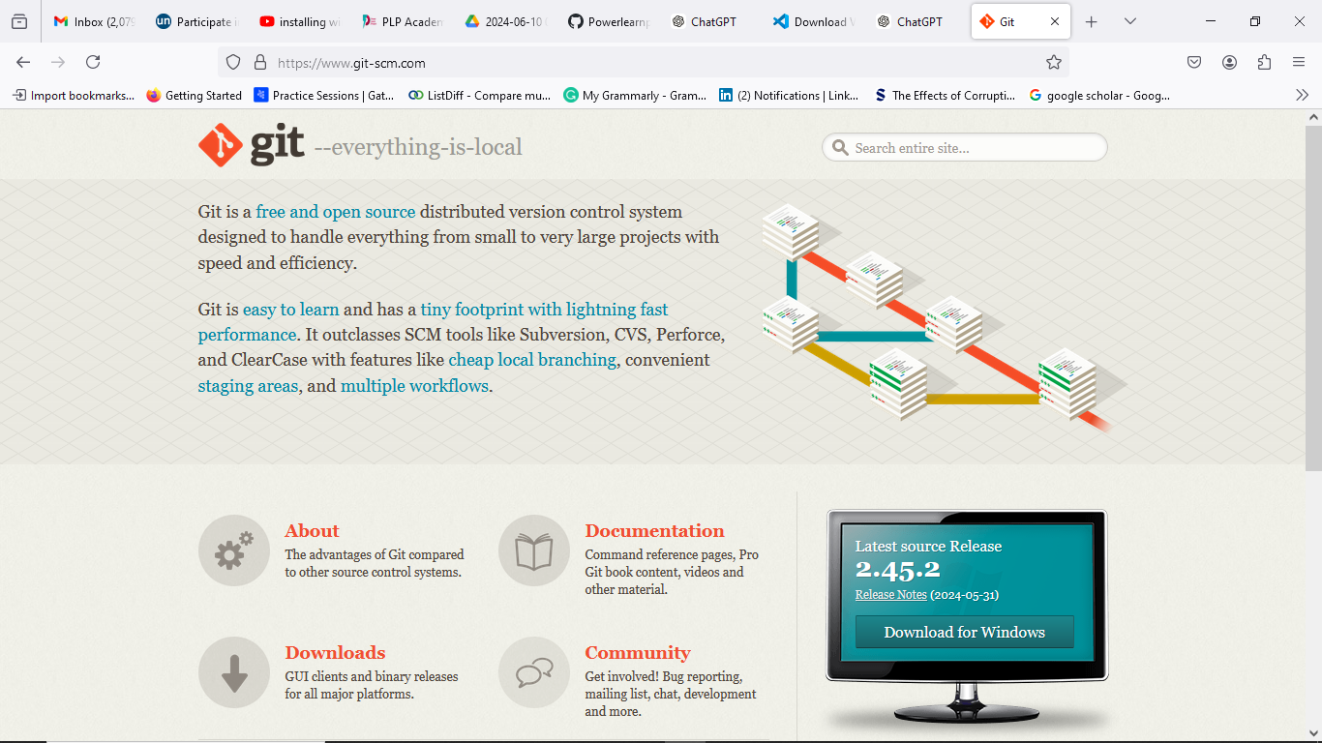

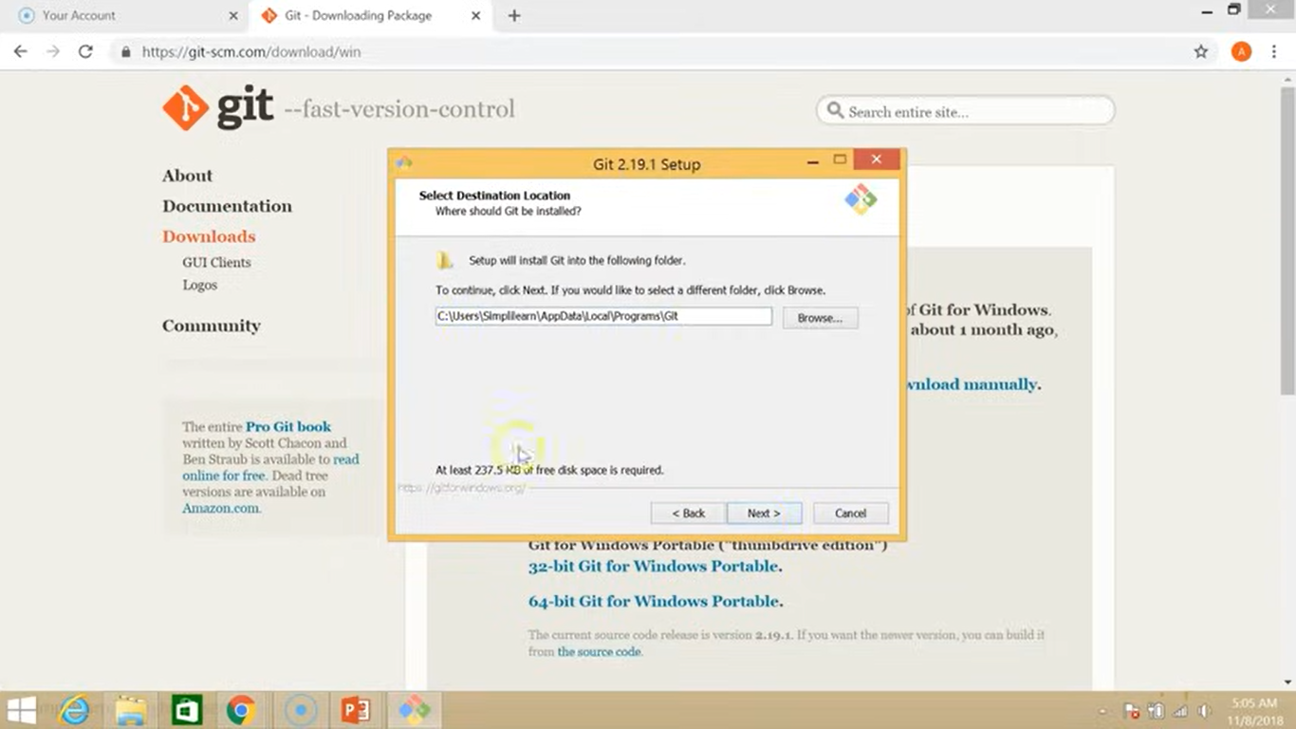

Below is the git bash interface after successful download and installation.  
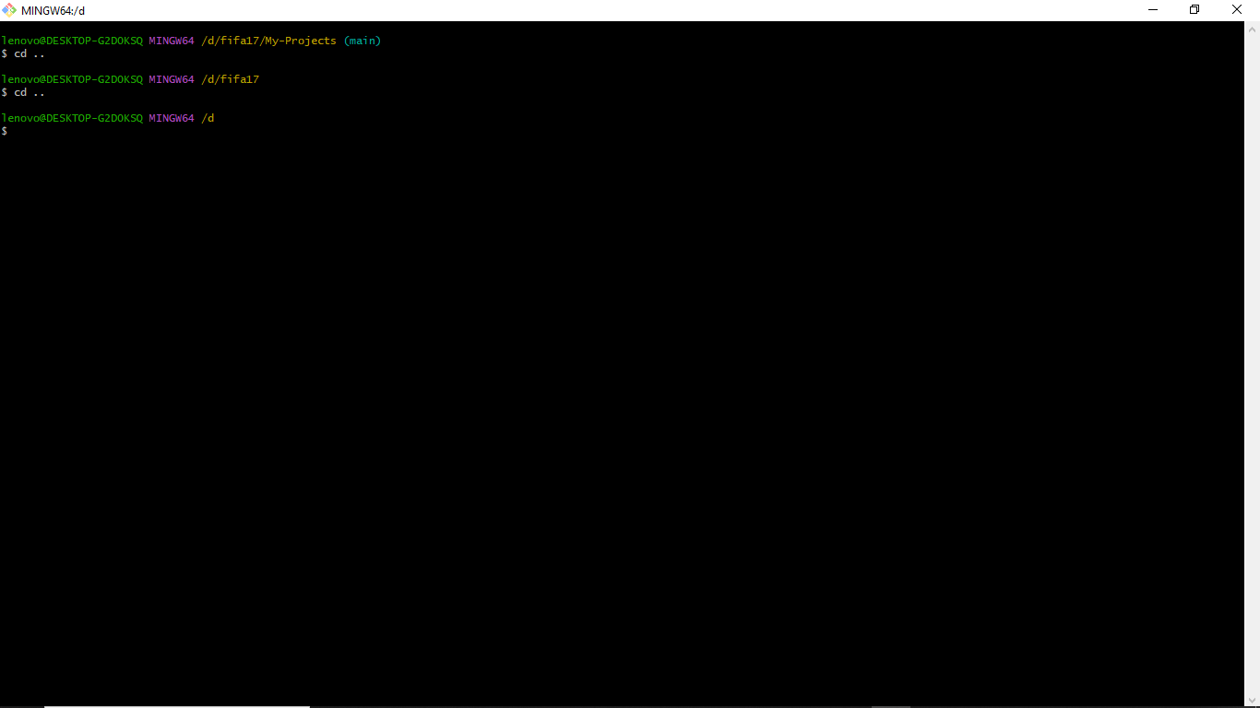

Below is a directory called test that I created and initialized:

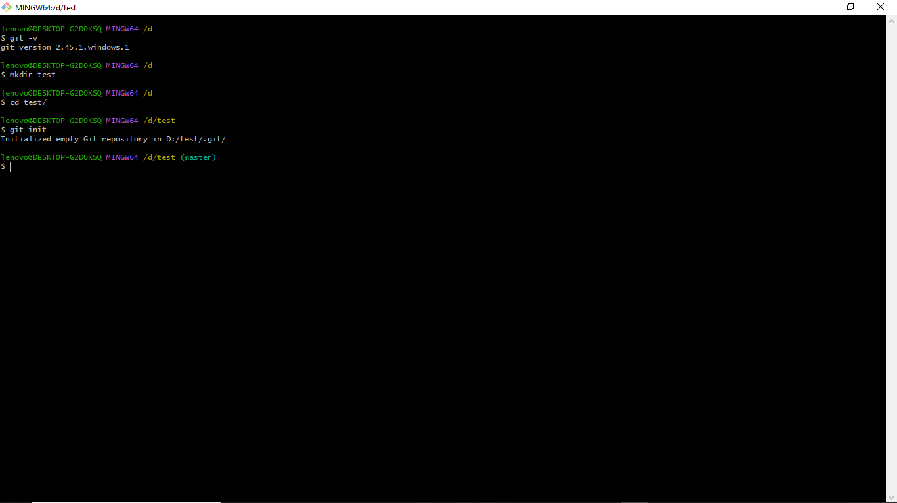Below is a screenshot of the aftermath after creating a file (Text.txt) in the directory.

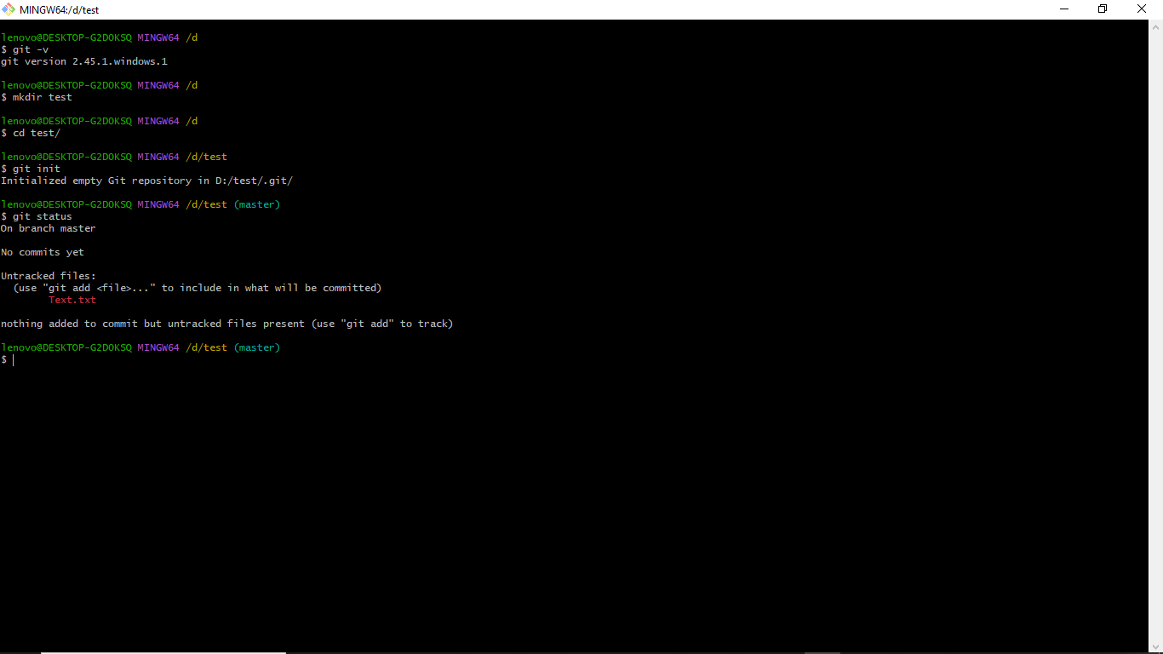In the screenshot below I did the following:

Added the Text.txt file to the current directory.

Next I committed the file with a message update.

Next I linked the git to github account.

After successful linking a created a github repository in my github account.

Next I linked the remote and local repository and pushed the file. 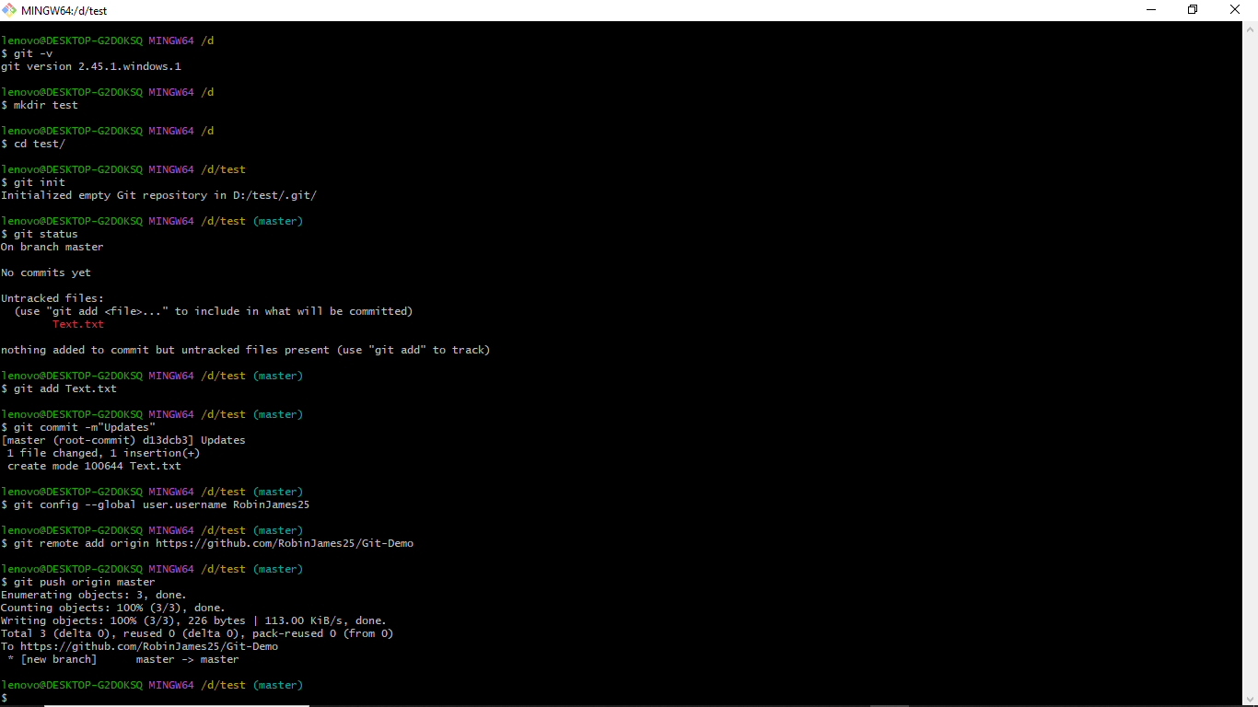Git hub repository I created with a file I just pushed in the screenshot below:

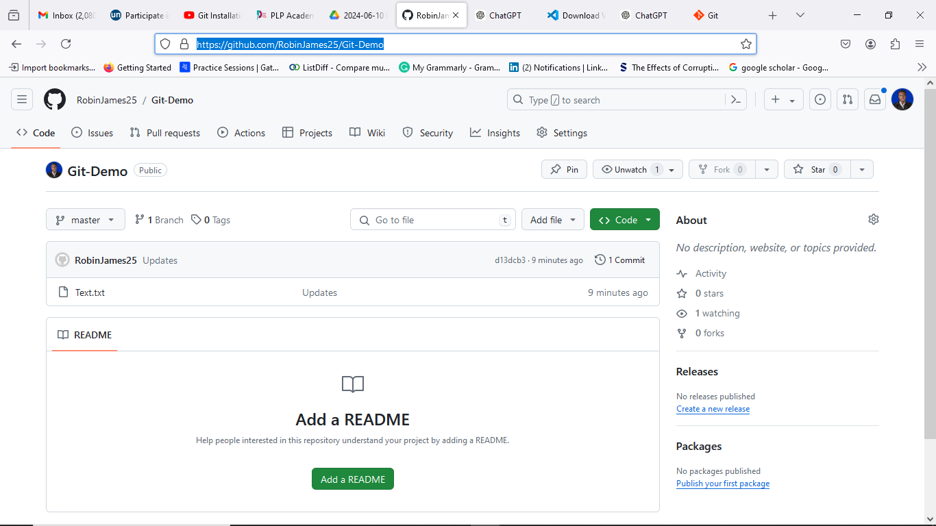

PYTHON INSTALLATION

I did the python installation from the following website link <https://www.python.org/downloads/>

And below are some of the screen shot of the website and setup:

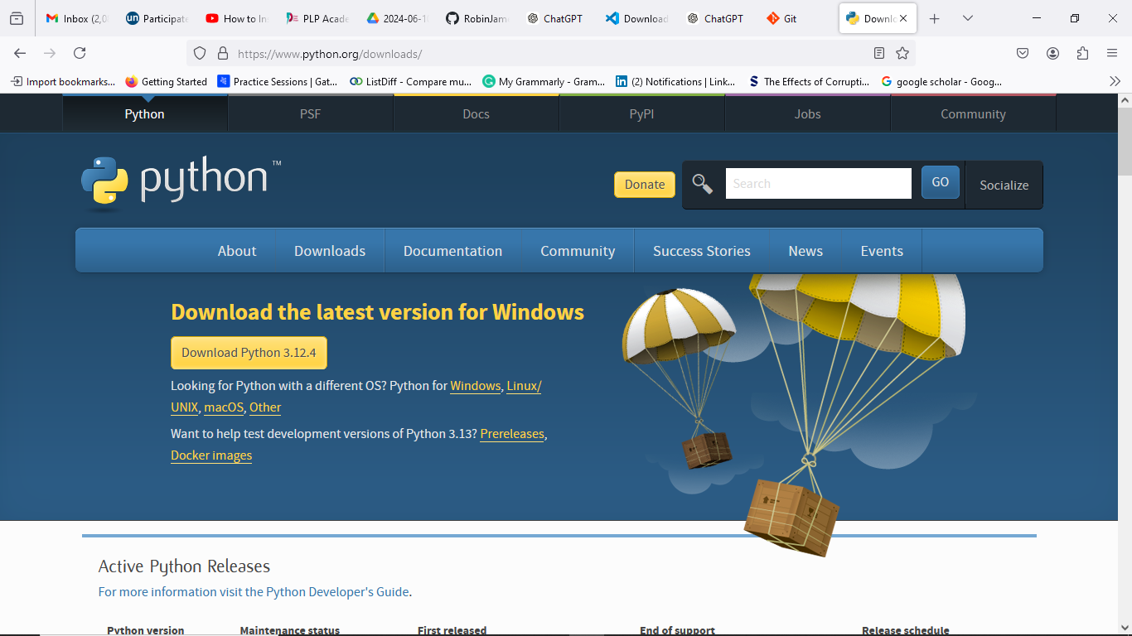

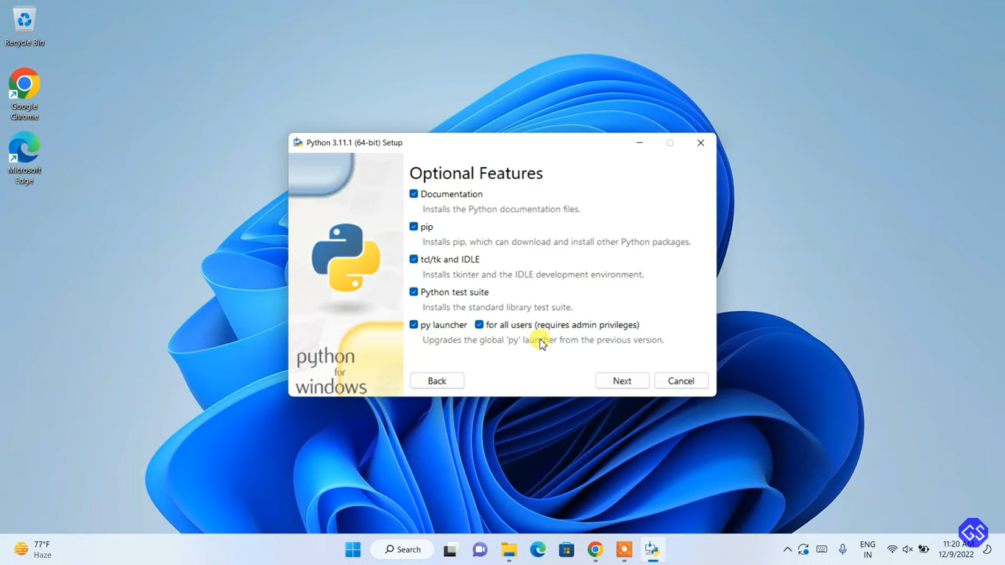

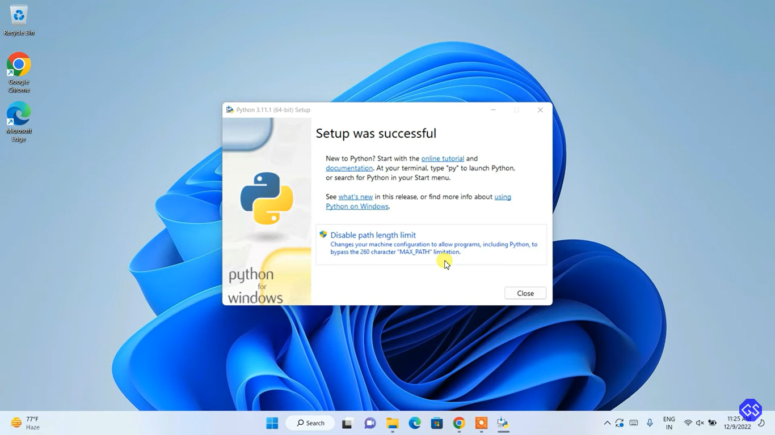

NB: Package managers like PIP came with python installation as seen in the screen shot above.

MY SQL DATABASE INSTALLATION

I downloaded my SQL from the following website:<https://dev.mysql.com/downloads/workbench/>

Below are some of the screenshots of the whole process:

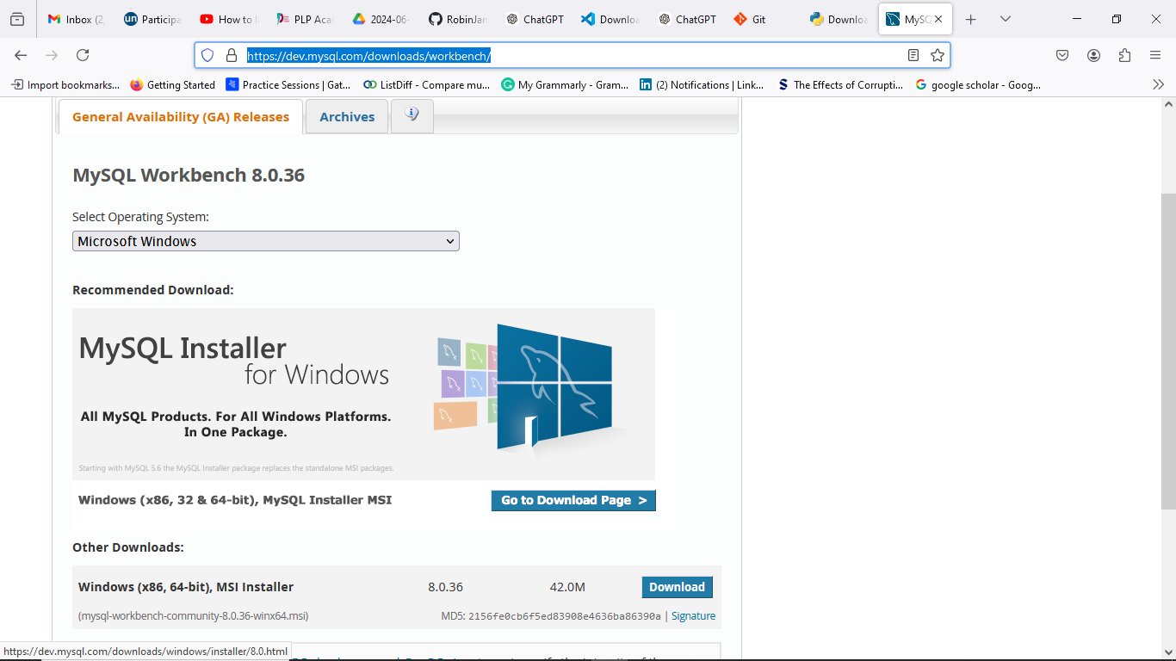

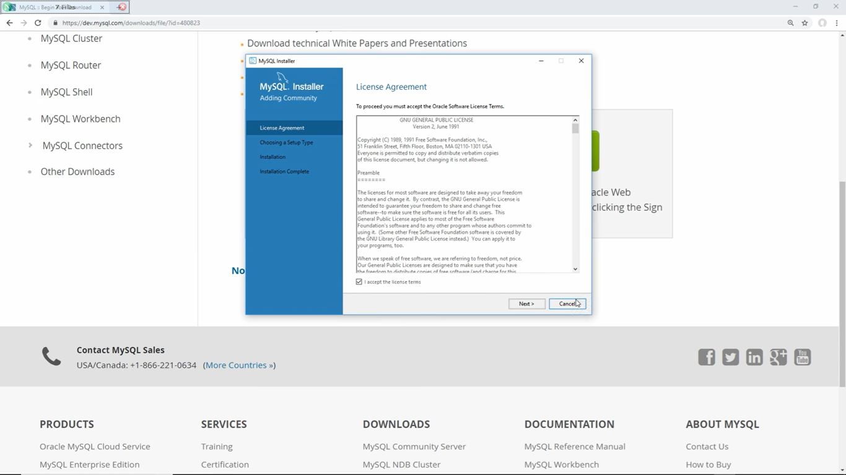

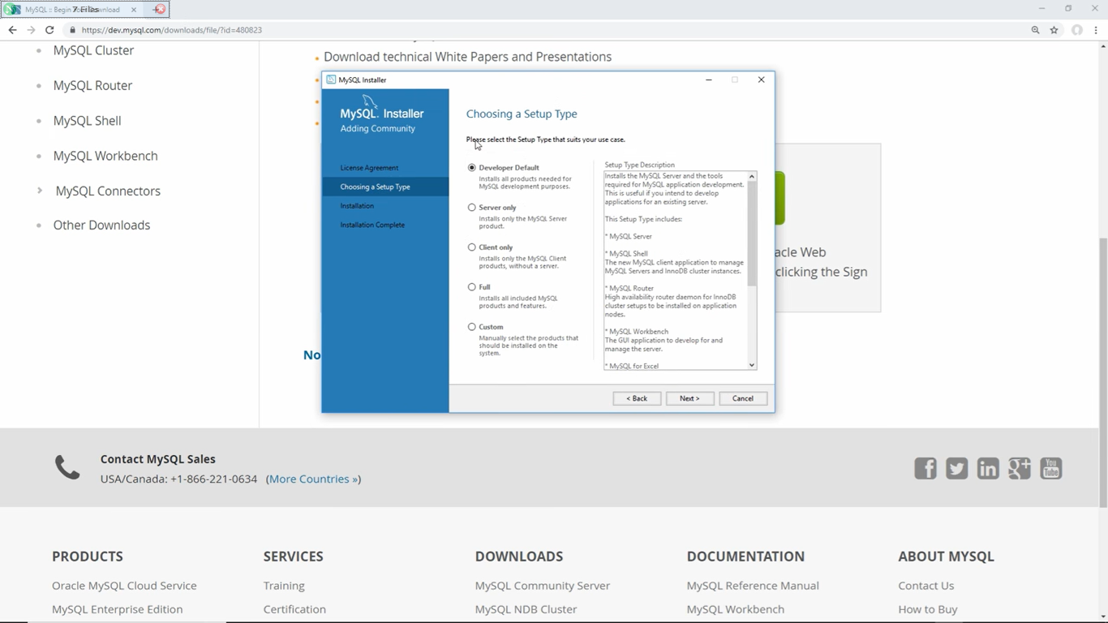

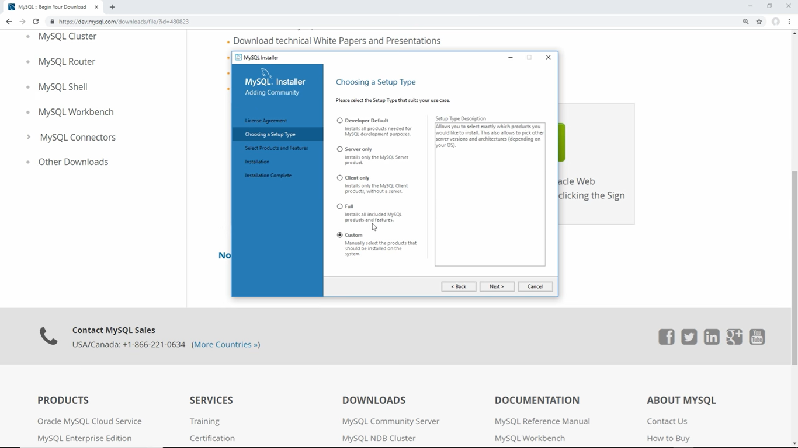

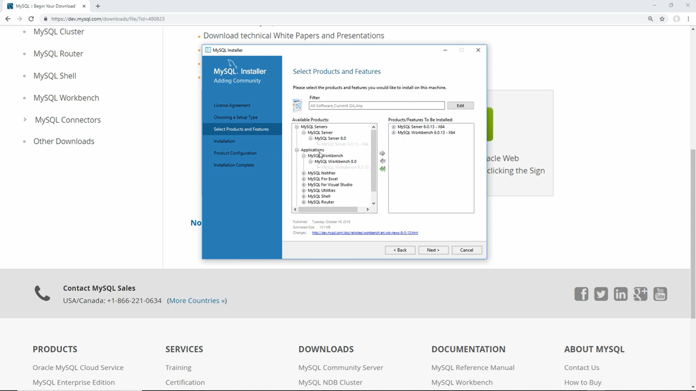

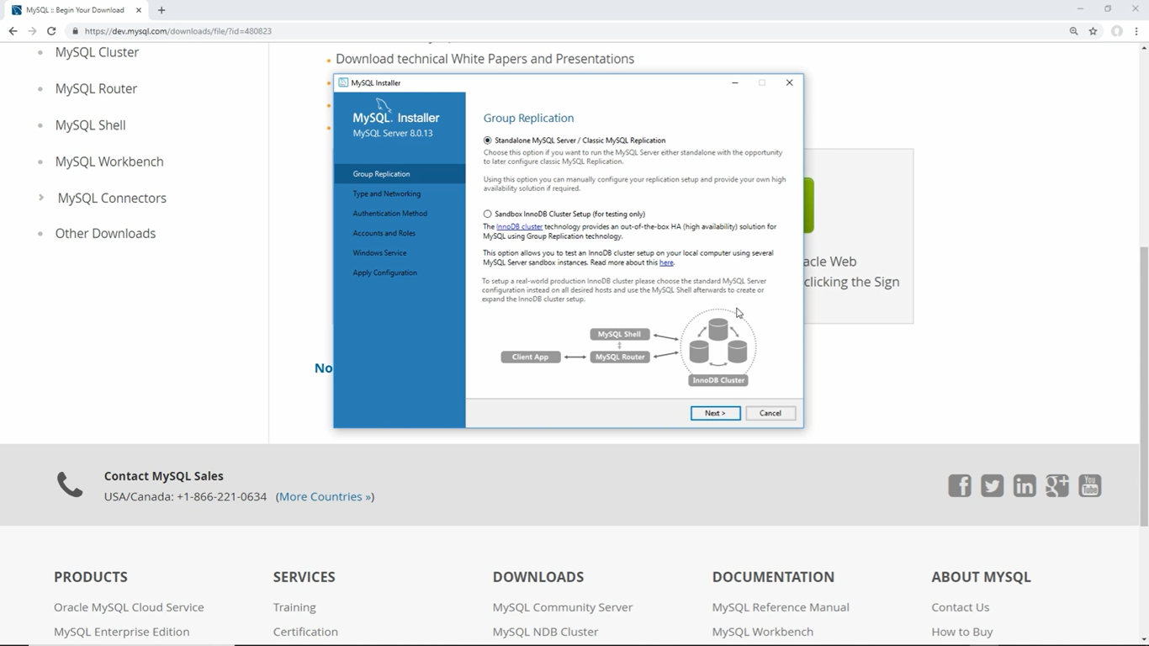

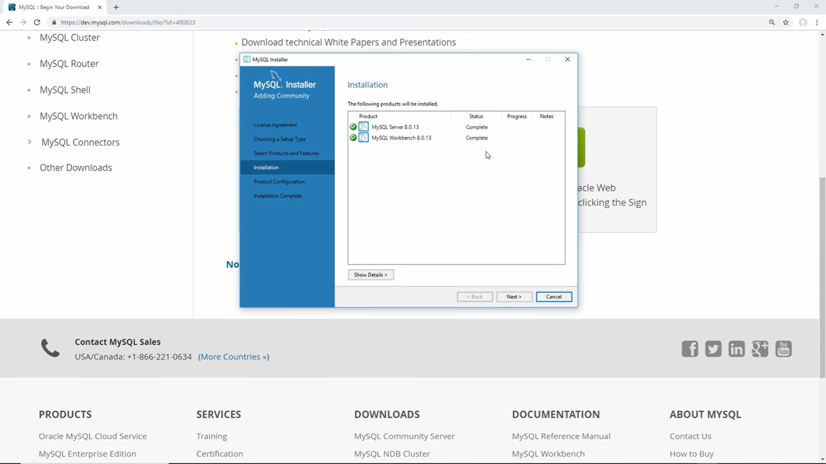

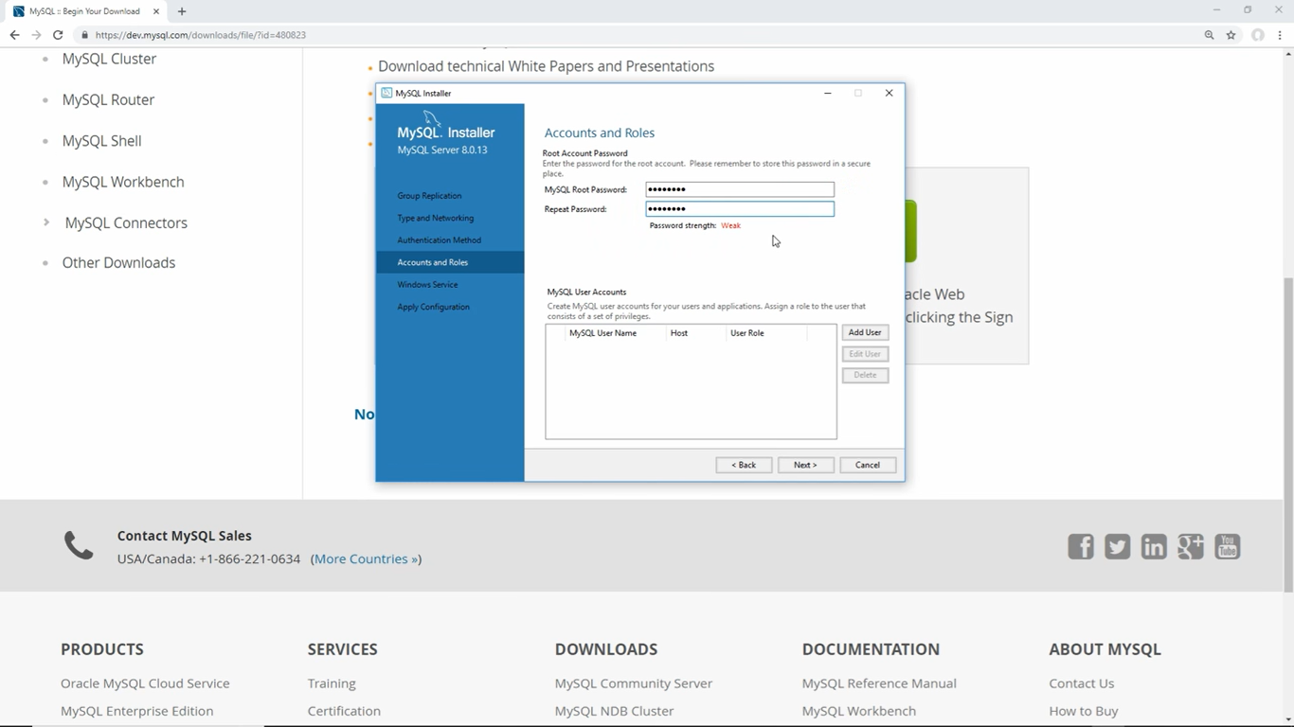

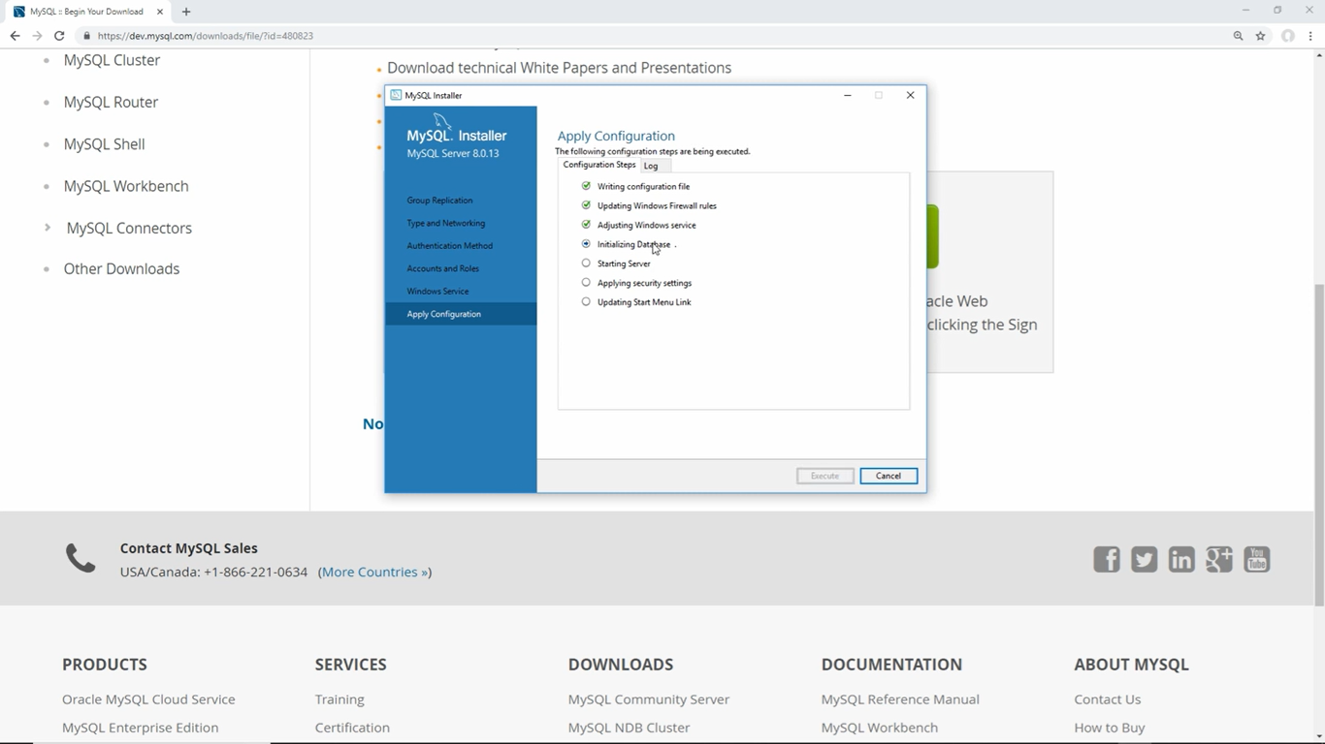

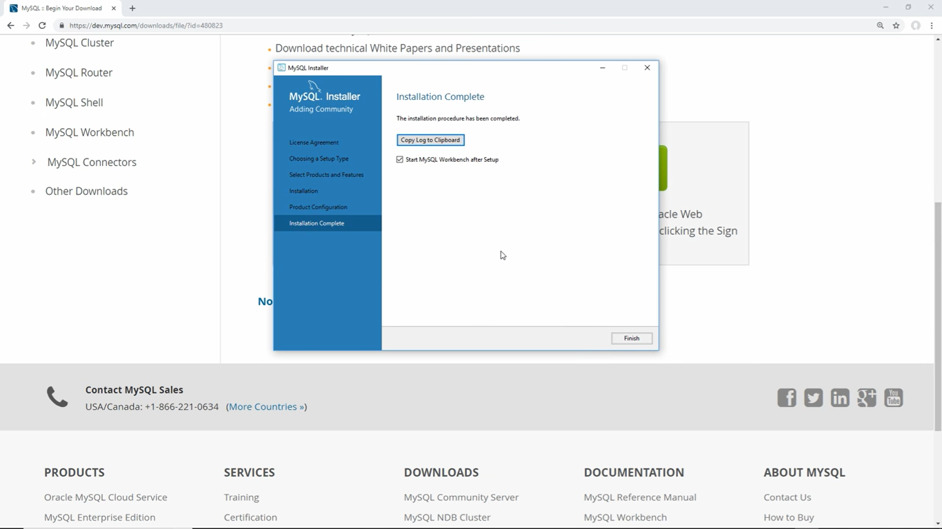

EXPLORING EXTENSIONS AND PLUG IN’S

Doing this I opened,my VISUAL STUDIO CODE and downloaded a few extensions:  
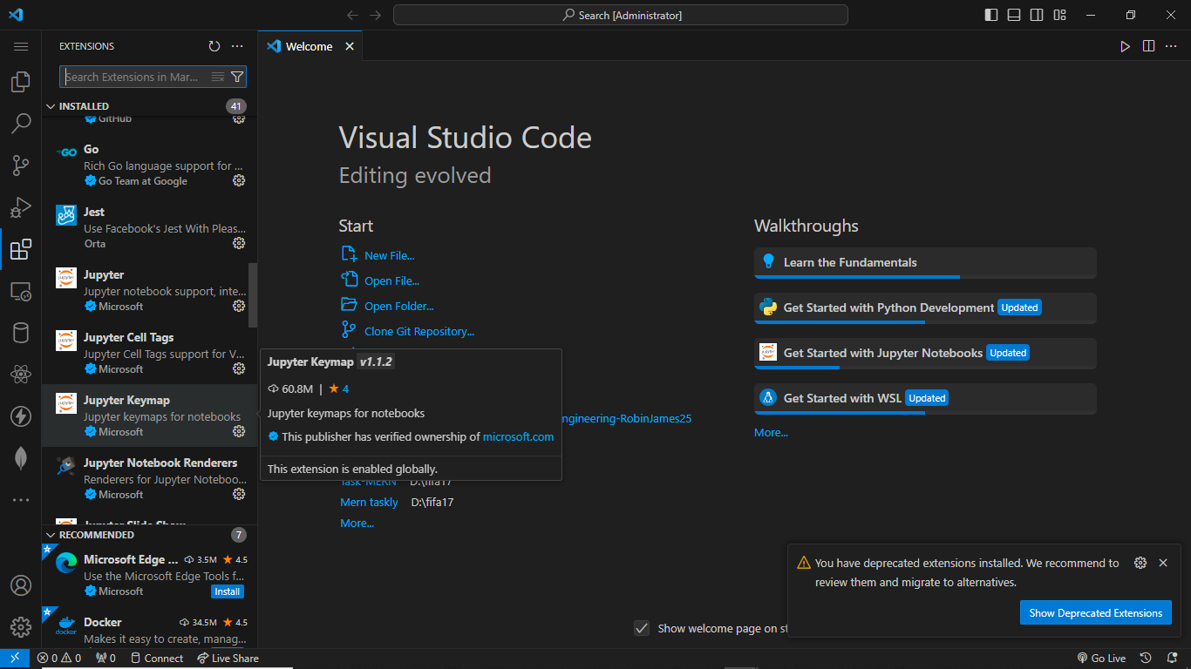

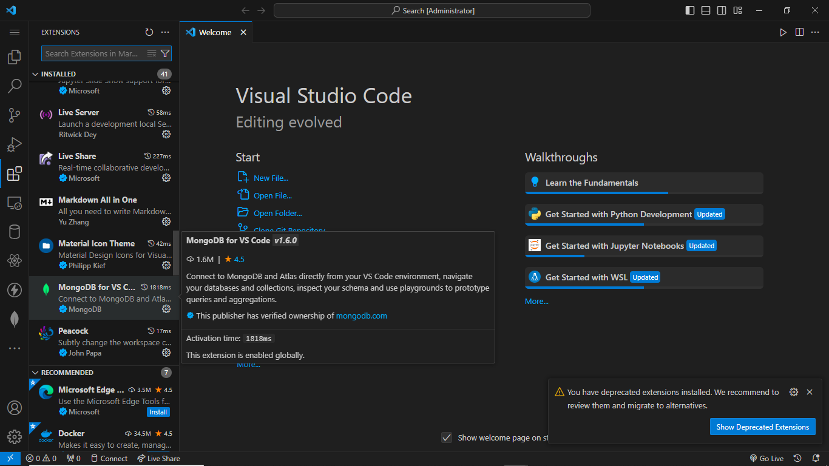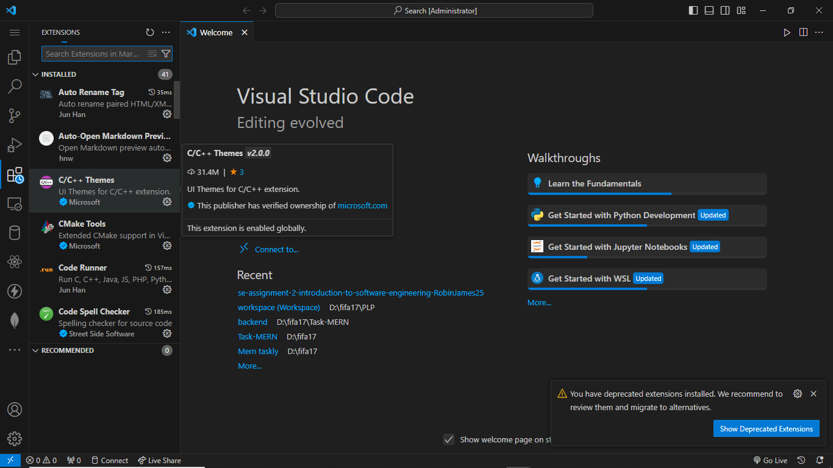

CHALLENGES ENCOUNTERED

Software Compatibility Issues

Configuration Errors

By troubleshooting these problems and seeking solutions, gained valuable problem-solving skills and resilience, which are crucial traits for any software developer.

Exploring the intricacies of software compatibility issues and resolving configuration errors has allowed me to improve my problem-solving skills and develop resilience. These qualities are essential for a proficient software developer adapting to the ever-changing world of technology..